**Reacting/Responding to Adversity 10/02/22**

The post WW2, global peace & prosperity, created by the US military in which we have lived is coming to an end, maybe not today but soon. As the world continues to evolve & unstoppable forces continue to shape the family of nations, what we have known & come to expect will change. We don’t know when or in exactly what way but conventional wisdom seems to say that this winter could be different than any in recent memory. Unnecessary lockdowns implemented by evil governments have busted the normal supply chains, making every day necessities hard to acquire. Canadian and European farmers are being put out of business for no reason and this will create food shortages all over the poorest parts of the world. Estimates of up to 1.2 Billion of the world’s poorest people will starve or freeze this winter because of the climate change utopian whackos who are destroying the world’s energy production. Inflation, purposely created by our government printing paper money will cause prices to soar for all of us, causing many to lose their homes. And still parts of the world are masking everyone and demanding they all shoot up with questionable, experimental potions.

The point is not to frighten us but to prepare us. What earthly, worldly things & situations are you unwilling to give up as these changes take effect? How spiritual oriented are your children? How committed are they to their earthly goals and priorities? Will they lose their peace when their earthly goals of prosperity go by the way side? Will you lose your confidence in the Lord when they lose theirs and they can’t be comforted in their suffering? Or will you choose to accept what God allows, knowing that everyone not walking with the Lord, including our kids and grandkids must suffer the consequences of their poor priority choices. Will you allow them to learn, or will you try to rescue them from the suffering they need to grow? Will you surrender to the Lord, submitting to the circumstances He allows in your life or will you try to hold onto your earthly agenda and grow bitter toward Him while trying to control the world around you? Learn from Cain.

**The First Gospel**

**Genesis 3:15** And I will put enmity between you and the woman, and between your seed and her seed; He shall bruise you on the head, And you shall bruise him on the heel."

* Proto-evangelism – first gospel – her seed Christ – your seed = unbelievers
* Seed of the Woman – sperma – woman has no seed = Virgin Birth

**Genesis 3:21** The LORD God made garments of skin for Adam and his wife, and clothed them.

* Animal sacrifice to clothe their nakedness with +R coverings – first animal sacrifice
* Animal sacrifice became the norm for portraying the person/work of Christ all through the Jewish Age with Moses codifying the different animal sacrifices.

**John 1:29 the next day he saw Jesus coming to him and said, "Behold, the Lamb of God who takes away the sin of the world!**

**Genesis 4:1**-8 Now the man had relations with his wife Eve, and she conceived and gave birth to Cain, and she said, "I have gotten a man child with *the help of* the LORD." 2 Again, she gave birth to his brother Abel. And Abel was a keeper of flocks, but Cain was a tiller of the ground. 3 So it came about in the course of time that Cain brought an offering to the LORD of the fruit of the ground. 4 Abel, on his part also brought of the firstlings of his flock and of their fat portions. And the LORD had regard for Abel and for his offering; 5 but for Cain and for his offering He had no regard. So Cain became very angry and his countenance fell. 6 Then the LORD said to Cain, "Why are you angry? And why has your countenance fallen? 7 "If you do well, will not *your countenance* be lifted up? And if you do not do well, sin is crouching at the door; and its desire is for you, but you must master it." 8 Cain told Abel his brother. And it came about when they were in the field, that Cain rose up against Abel his brother and killed him.

**Genesis 4:1** now the man had relations with his wife Eve, and she conceived and gave birth to Cain, and she said, "I have gotten a child with the help of the LORD."

* Grace orientation – I have acquired a male child with the help of the Lord – she knew that she was unable to create life – only God can “bara” life

2 Again, she gave birth to his brother Abel. And Abel was a keeper of flocks, but Cain was a tiller of the ground.

* Different, important professions, crops and flocks – nothing wrong with tilling the ground for crops

*3 So it came about in the course of time that Cain brought an offering to the LORD of the fruit of the ground. 4 Abel, on his part also brought of the firstlings of his flock and of their fat portions.*

* Course of time – apparently God had given A/E – family a proper day for worship & sacrifice
* Required sacrifice was an animal representing the Person/Work of coming seed of the woman

*And the LORD had regard for Abel and for his offering;*

* Regard – to gaze upon Abel (faith & obedience) & offering (proper) with approval
* Reading Paul back into the OT we conclude that the issue of sin & the future offering for sin (gospel) had been taught and understood – Faith & obedience brought animal sacrifice to portray the gospel

*5 but for Cain and for his offering He had no regard.*

* God looked upon Cain (independent & resistant) & his offering (his human best) with disapproval
* God is not looking for the best of our humanity – “**I am doing my best”**

1. **Many people & many believers look at their lives, realizing that they continue to fall short of the life of radical honesty & unconditional love they have been given.**

* Mankind naturally turns to habitual human methods that have developed all through our lives – effort
* We are naturally socially concerned & connected and therefore use our developed human strategies & abilities to form & project an image of ourselves that we think meets the criteria for success.
* As new Christians, we learn what we should appear to be, what to do or not do and we fall in step with those around us, imitating those we consider successful – P-T took on personality of RBT.
* We are saved, secure, in union with Christ, indwelt by GHS, walking in GHS, exercising spiritual gift but still plagued by guilt, shame, fear, anger & bitterness based on unconscious false beliefs

1. **We look at our flaws & relational struggles, telling ourselves that “I am giving it my best effort” not realizing that our best effort has nothing to do with the supernatural Christian life.**

* Doing our best & giving God our best rather than making the effort to learn, understand & apply the principles of transformation is a sin natural approach to living the CWL.
* Constructing a “Christian” persona of niceness through human means to appear spiritual, while leaving your verbal/visual thoughts, beliefs & motives unexamined is not the CWL.
* When the patterns & cycles of your relationships don’t change & improve over time, it indicates that real changes are not taking place within where the CWL is won or lost.

1. **Every person initially forms an OM belief system out of personal experience from the ideas of the devil’s world that becomes the foundation of our thoughts (verbal – visual), emotions, words & actions.**

* At birth: born spiritually separated from God, unable to comprehend God, with a corrupted nature, into a family of sinners, into the devil’s world, with inherited predispositions & knowing nothing.
* Our needs/desires drive us to find objects (people, possessions & situations) to which we attach ourselves through faith, by believing that these proper earthly blessings can fulfill us.
* Our OM beliefs are programmed in first, habituated through consistent us first and are the dominant force in our thoughts, feelings and actions – why we can’t seem to break free

1. **The Christian Way of Life (CWL) is a supernatural life produced by the power of GHS illuminating the true beliefs of Jesus & enabling the believer to live them out through their soul.**

* Learning categorical bible truths, assembling them in your mind to form a Christ centered belief system
* The Christ centered beliefs + power of GHS create the capacity to emulate the thinking, feeling, words & actions of Christ in our relationships and daily lives.
* It is necessary to lay aside our original beliefs, expectations and relational strategies to allow GHS to make Christian beliefs & character the operating system of our lives

**Ephesians 4:22** that, in reference to your former manner of life, you lay aside the old self, which is being corrupted in accordance with the lusts of deceit, 23 and that you be renewed in the spirit of your mind, 24 and put on the new self, which in *the likeness of* God has been created in righteousness and holiness of the truth.

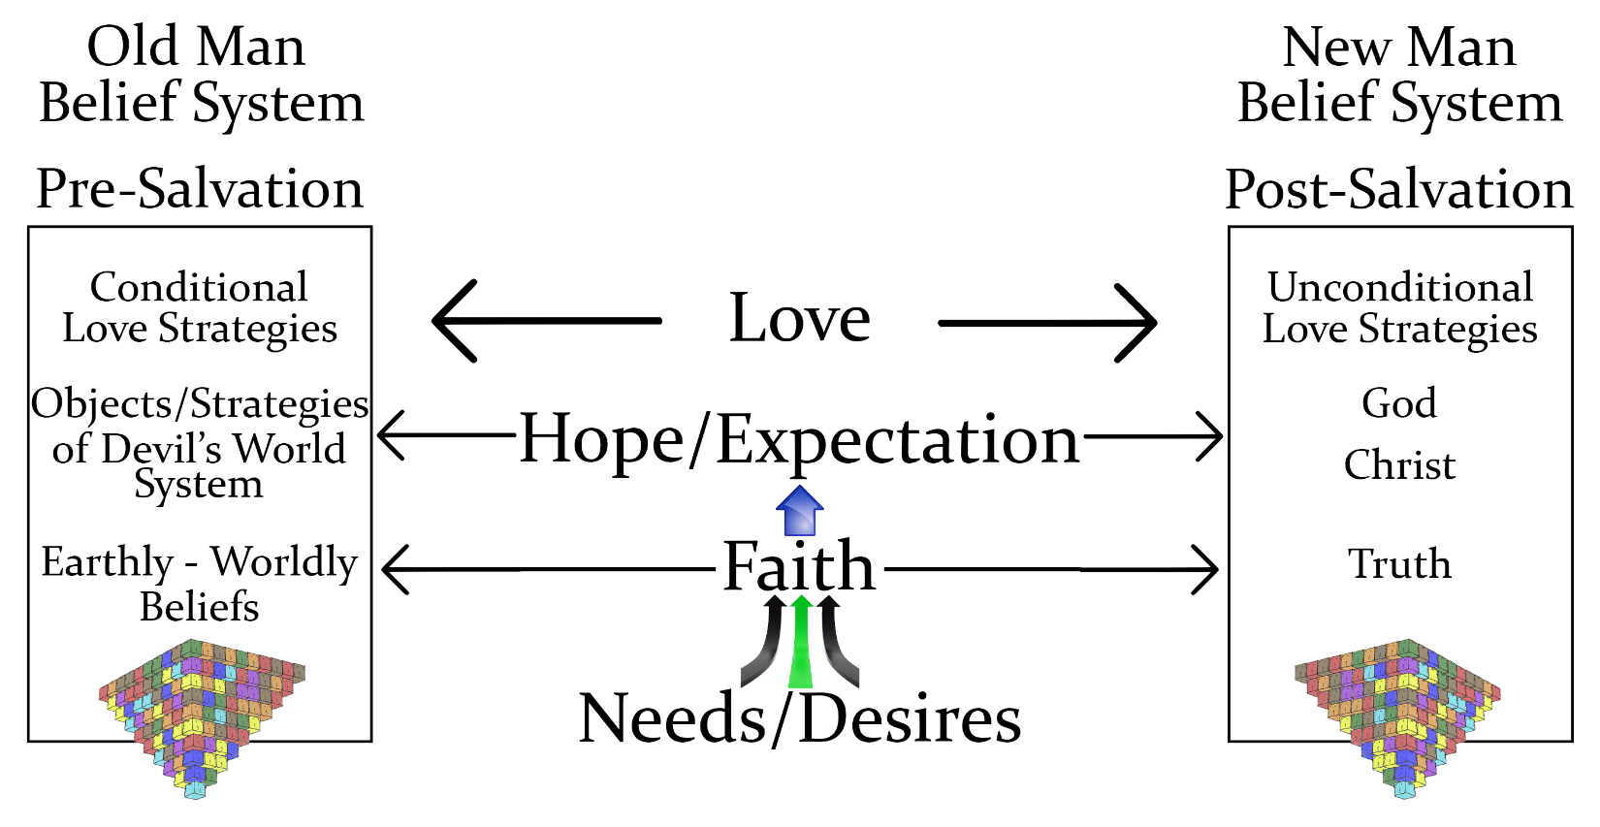

*So Cain became very angry and his countenance fell.*

1. **Cain’s original approach was to create his own plan by believing that he could bring the best of his human ability & production to God and that God would be pleased with his best.**

* Every human being initially develops their own plan – ideas – beliefs based on their abilities, about how to find happiness in life, expecting their plan to work.

1. **God rejected Cain’s plan and offering because his plan didn’t submit to God’s plan.**

* Our plans based on OM beliefs from the world’s kosmic system will never produce happiness we need, desire and intend because it is not His plan nor are we surrendered to Him.

1. **When our plans inevitably fail, our natural temptation & tendency is to become angry, resentful and blame others and even God for not supporting your plan.**

* When adversity & loss inevitably come to your life, you must choose to reject blame & bitterness by choosing to believe that God has the right to allow you to experience loss and that in fact, it is a gift to help purify heart, sanctify your conscience & resolve the inner conflicts in your soul.

**1 Timothy 1:5** But the goal of our teaching is love from a pure heart (transformed by removing the lies & embracing the truth) and a good (agathos – divinely ordered) conscience and a faith minus any hypocrisy (double minded).

*6 Then the LORD said to Cain, "Why are you angry? And why has your countenance fallen?”*

* Does God know why Cain is angry and why he is walking around angry & resentful?
* He is asking to inspire Cain to search for the root cause of his hurt, pain & bitterness

1. *"If you choose rightly (bring proper sacrifice), will not your countenance be lifted up?”*
2. **If you believe & obey, you will be saved, I will give you my approval and lead you into true happiness**

* Going right means to trust & obey what God says

*And if you do not do well, sin is crouching at the door; and its desire is for you, but you must master it."*

1. **Don’t do right – if Cain holds onto his belief that his best ought to be good enough for God & that he has no intention of bending the knee to God by getting an animal from his brother to sacrifice**

* Only a very few people are willing to give up on their plan to replace it with God’s plan – most continue believing that their plan will work with self-improvement, different people or circumstances.

1. **Sin like a ravenous beast is lying in wait to eat you – it desires to master you but you must master it.**

* Description of sin – an animal with insatiable hunger that desires to control you & eat you alive.
* The only way to master sin is to accept the free gift of salvation which the animal sacrifice portrayed
* If Cain allowed his sin of anger & bitterness to take control of him, his sin would take him to the furthest extremes to satisfy its evil & hateful desires - murder

*8 Cain invited Abel his brother to go into the field. And it came about when they were in the field, that Cain rose up against Abel his brother and killed him.*

1. Cain’s reaction to the loss of the expected success & approval of his plan as opposed to God’s plan for him was to allow anger to fester into bitterness & hatred and then into murder of his own brother.
2. When the loss of a temporal person, possession or situation comes to your life, will you become bitter and become an unwelcome monster or will you surrender to God, trusting that He is doing what is best for His plan and for your loved ones, while rooting out any ideas that cause you to react to Him.

**Isaiah 26:3** **"The one whose mind leans on you, you will keep in perfect peace, because he trusts in You.”**